**ASSIGNMENT 4**

1. Write a C program to print **Hello Students** on the screen.

**Ans.** //program to print **Hello Students** on the screen

#include<stdio.h>

#include<conio.h>

Int main()

{

printf(“Hello Students”);

getch();

}

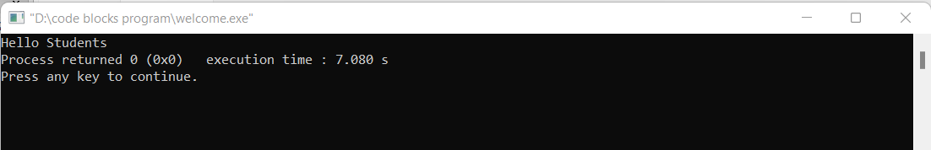

1. Write a C program to print **Hello** on the first line and **Students** in the second line.

**Ans**. //program to print **Hello** on the first line and **Students** in second line

#include<stdio.h>

#include<conio.h>

Int main()

{

printf(“Hello \nStudents”);

getch();

}

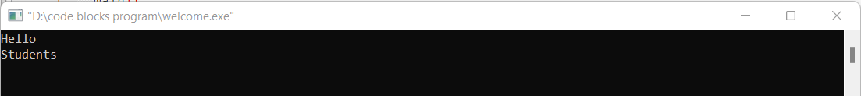

1. Write a C program to print **“MySirG”** on the screen.

**Ans.** //program to print **“MySirG”** on the screen

#include<stdio.h>

#include<conio.h>

Int main()

{

printf(“\“MySirG\””);

getch();

}

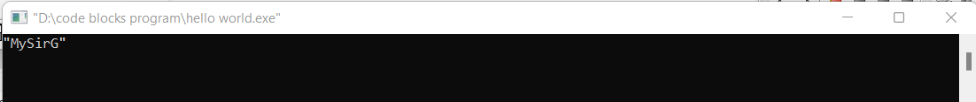

1. WAP to find the area of the circle. Take radius of circle from user as input and print the result in below given format.

**Ans.** //find area of circle. Take radius from user

#include<stdio.h>

#include<conio.h>

#define PI3.14

main()

{

int r;

float PI, area;

printf("Enter the value of radius");

scanf("%d",&r);

PI=3.14;

area= PI*r*r;

printf("the area of circle is %f",area);

getch();

}

1. WAP to calculate the length of string using printf function.

//calculate the length of string using printf function

#include<stdio.h>

#include<conio.h>

Int main()

{

Int x= printf(“Ineuron”);

Printf(“%d”,X);

Return 0;

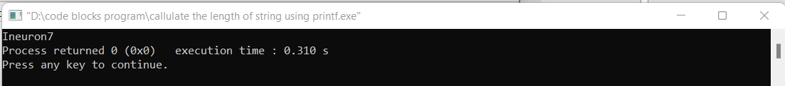

1. WAP to print the name of the user in double quotes.

Expected output format- **“Hello, Amit Kumar”**.

**Ans.**  //program to print **“\n”** on the screen

#include<stdio.h>

#include<conio.h>

Int main()

{

printf("\"Hello, Amit kumar\"");

getch();

}

1. Write a program to print **%d** on the screen.

**Ans.** //program to print **“%d”** on the screen

#include<stdio.h>

#include<conio.h>

Int main()

{

printf(“%%d”);

getch();

}

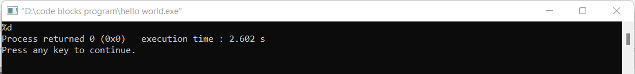

1. Write a program to print **\n** on the screen

**Ans.**  //program to print **“\n”** on the screen

#include<stdio.h>

#include<conio.h>

Int main()

{

printf(“\\n”);

getch();

}

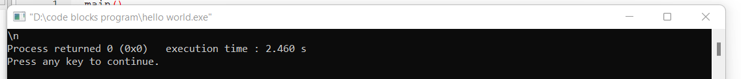

1. WAP to print **“\\”** on the screen.

Ans. //program to print **“\\”** on the screen

#include<stdio.h>

#include<conio.h>

Int main()

{

printf(“\\\\”);

getch();

}



1. WAP to take time as an input in below given format and convert the date format and display the result as given below.

User Input date format- “DD/MM/YYYY”

Output format- “Day- DD, Month- MM, Year- YYYY”

**Ans.** #include<stdio.h>

#include<conio.h>

int main()

{

int mm, dd, yyyy;

printf("Enter date in DD/MM/YYYY format\n");

scanf("%d/%d/%d",&mm, &dd, &yyyy);

printf("day- %d month- %d year-%d",mm,dd,yyyy);

getch();

return 0;

}

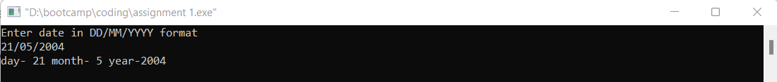

1. WAP to take time as an input in below given format and convert the time format and display the result as given below.

User Input date format- “HH:MM”

Output format- “HH hour and MM Minute”

**Ans.** #include<stdio.h>

#include<conio.h>

int main()

{

int HH, MM;

printf("Enter date in HH:MM format\n");

scanf("%d:%d",&HH, &MM);

printf("%d hour and %d minute",HH,MM);

getch();

}

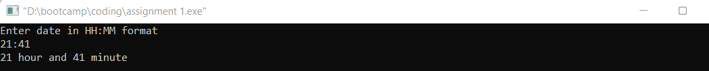

1. Find output of below code:

int main()

{

int x = printf(“ineuron”);

printf(“%d”,x);

return 0;

}

**Ans.**



Thank You!!